ENGLISH LANGUAGE DAY 2024

Lead in
https://forms.office.com/e/QwqdGFnwK2
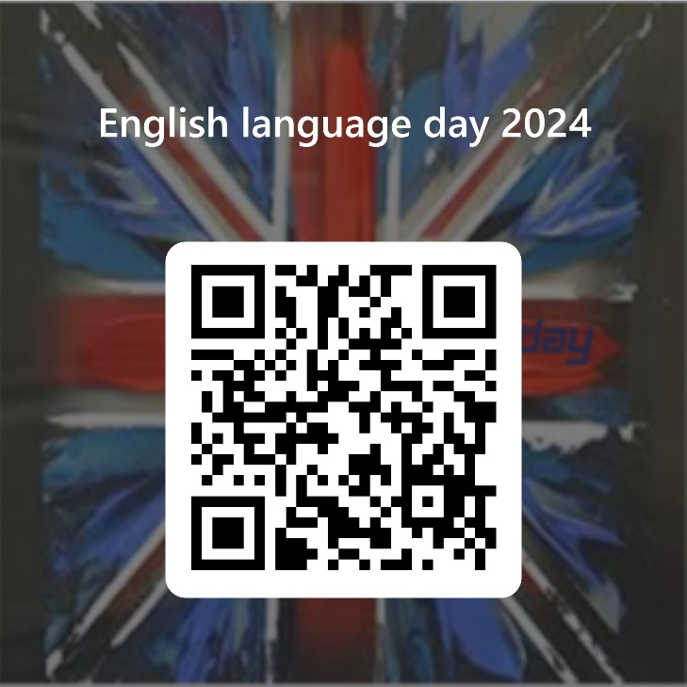

Main part
TASK 1
www.bing.com/videos/riverview/relatedvideo?&q=english+language+day+2024&&mid=8CD8CEB9795FD7B3300C8CD8CEB9795FD7B3300C&&FORM=VRDGAR
While watching the video write 3 things that led to the English language becoming a global lingua franca.

TASK 2
Answer the questions:
1. Why is learning English important for you?
2. How much time do you spend learning English weekly?
3. What is your favourite way of learning English?
4. Which activities do you find most interesting/ difficult in learning English?

TASK 3
Fill in your English file and have fun!
MY ENGLISH FILE
Name and surname:

1. I like the English language because_______________________________________________.
2. My favourite greeting in English is _______________________________________________.
3. My favourite variety of English is ________________________________________________
(British, Scottish, Irish, North American, Australian, New Zealand English…).
4. My favourite saying in the English language is____________________________________________________________________________.
5. My favourite English word is ___________________________________________________.
6. One English writer I have heard and read is________________________________________.
He/She is the author of (which book/ song)__________________________________________.
7. My favourite song in the English language is______________________________________.
Its most famous line is__________________________________________________________.
8. My favourite English movie is___________________________________________________.
9. The best joke in the English language I have heard of is___________________________________________________________________________.
10. The best idiom in the English language for me is _____________________________________________________________________________.
11. My favourite Internet site in the English language is________________________________.
12. My favourite application in the English langage is _________________________________.
13. If I had an English name it would be _____________________________________________.
15. The most challenging part of learning the English language for me is
_____________________________________________________________________________.
16. My favourite English speaking country and city are _______________________________.
17. My favourite English teacher so far has been _____________________________________.
18. Add an interesting question on the English language and give an answer. ___________________________________________________________________________________________________________________________________________________________.
19. Draw something that reminds you of the English language and the things learning it.
HAPPY ENGLISH LANGUAGE DAY 2024!

Closure
Reading the files together.
Pinning them on boards.

